## **Compass Rose**

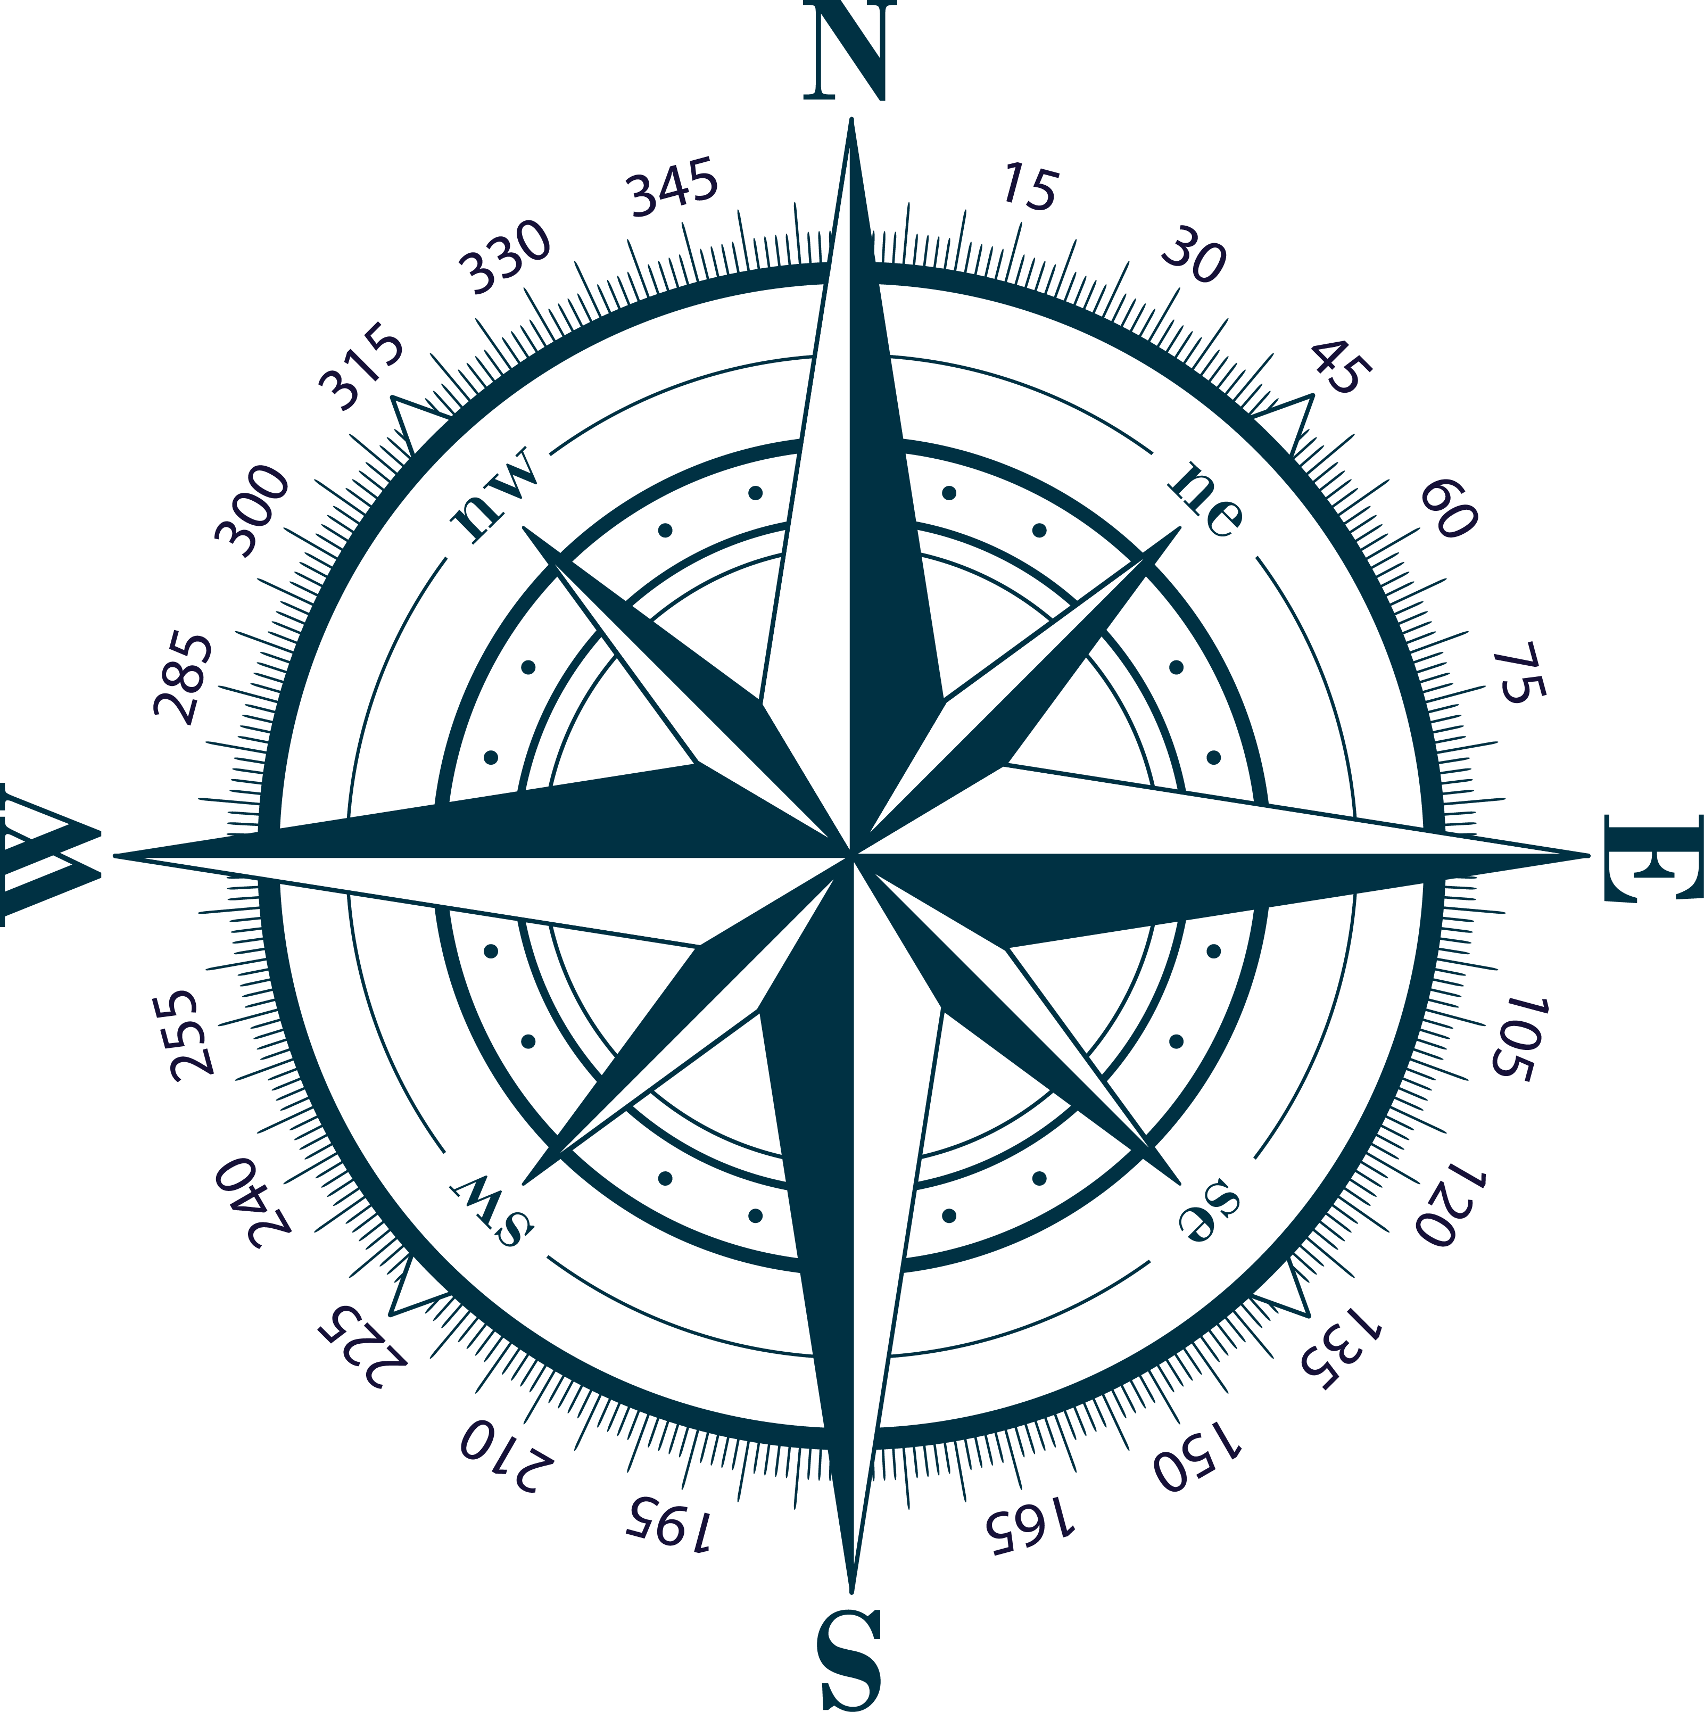

Clockwise the degrees (°) increase and anti-clockwise the degrees decrease.

**Example 1:**

Say the current heading is 0° and the required heading is 30°.

Curr = 0°

New = 30°

**Curr < New** (less than) therefore we must turn **clockwise**, i.e. turn to the **right** to increase the heading from 0° to 30°.

## **Small Turn Angle**

It is also desirable to keep the turn angle as small as possible.

In the example below to change your heading from 0° to 270° would require a 270° turn to the right. But **turning left** would only require a 90° turn.

So, if the difference between New and Curr is greater than 180° then the opposite angle would be smaller. Therefore, a turn to the **left** would get to the new heading faster.

## **Optimised Turn Angle Examples**

**Example 2:**

Say the current heading is 340° and the required new heading is 30°.

Curr = 340°

New = 30°

**Curr > New** (greater than) therefore we must turn **anti-clockwise**, i.e. turn to the **left** to decrease the heading from 340° to 30°.

But does this result in the smallest turn angle?

What is the difference between Curr and New?

Curr – New = 340° – 30° = 310° which is **greater** than 180°.

Which means the opposite angle would be smaller, (360° – 340°) + 30° = 50° instead of 310°.

Therefore, **turning** **right**, **clockwise** would be more efficient.

**Example 3:**

Say the current heading is 340° and the required new heading is 220°.

Curr = 340°

New = 220°

**Curr > New** therefore we must turn **anti-clockwise**, i.e. turn to the **left** to decrease the current heading from 340° to the desired new heading of 220°.

Check for smallest turn angle:

Curr – New = 340° – 220° = 120° which is **less** than 180°.

Which means the **left turn angle** is the smallest and turning **left** is the **best**.

**Example 4:**

Say the current heading is 0° and the required new heading is 220°.

Curr = 0°

New = 220°

**Curr < New** therefore we must turn **clockwise**, i.e. turn to the **right** to increase the current heading from 0° to the desired new heading of 220°.

Check for smallest turn angle

New - Curr = 220° – 0° = 220° which is **greater** than 180°.

Which means a **left** turn, **anti-clockwise**, must be made as the **left turn angle** is the best.

**Code**

if curr_heading > target_heading:

if curr_heading - target_heading > 180:

turn_right()

else:

turn_left()

else:

if target_heading - curr_heading > 180:

turn_left()

else:

turn_right()